**МУДРЫЕ МЫСЛИ**

|  |  |
| --- | --- |
|  |  |

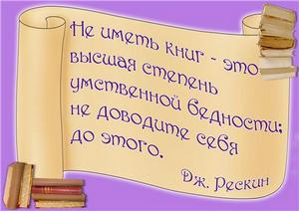    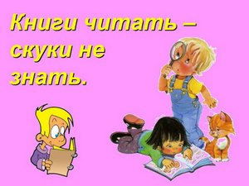

      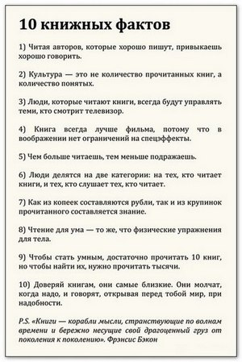       



|  |  |  |  |
| --- | --- | --- | --- |
| |  |  |  | | --- | --- | --- | | |  |  | | --- | --- | | http://biblioteka.ucoz.com.br/_tbkp/mudrye_mysli_o_knige-1.jpg | http://biblioteka.ucoz.com.br/_tbkp/mudrye_mysli_o_knige-4.jpg_300.gif http://biblioteka.ucoz.com.br/_tbkp/mudrye_mysli_o_knige-5.jpg300.jpg | | |

